The security assessment of the Tim Hortons Android app (v7.1.487) reveals a mixed security posture. While the SQLite database implementation appears secure with no sensitive data exposure, critical vulnerabilities were identified in the shared preferences storage, including exposed authentication tokens, personal identifiable information (PII), and insecure credential storage.
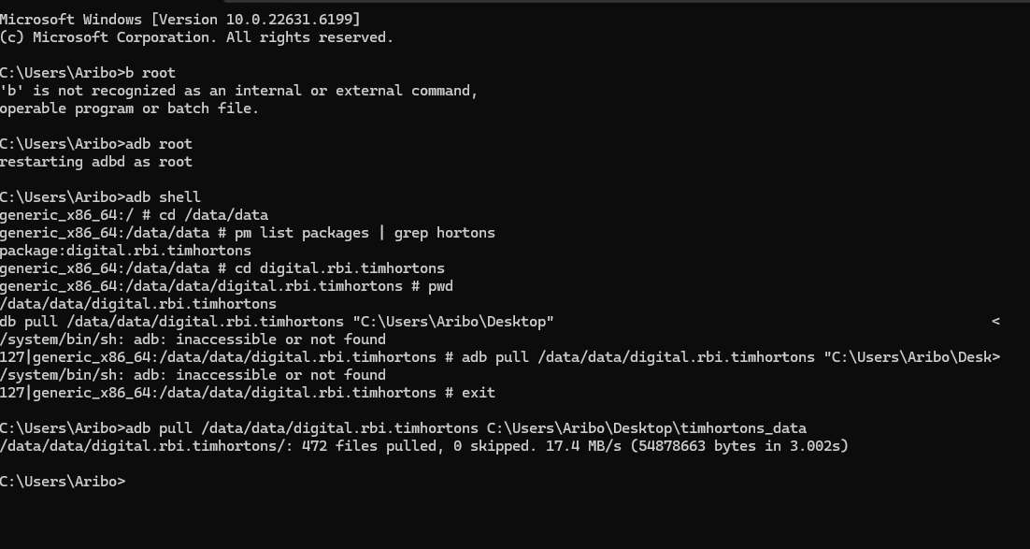
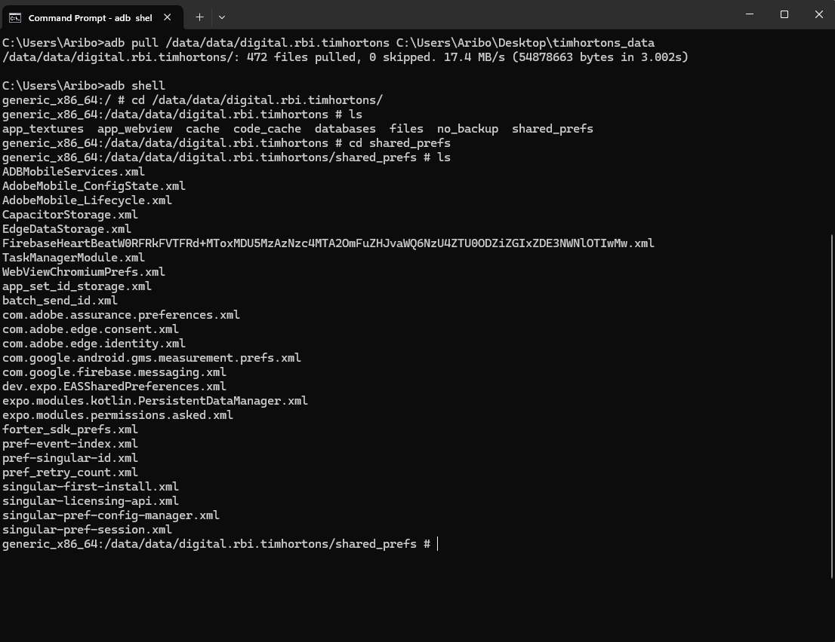

Assessment Overview
Database Security Assessment - PASS
Files Analyzed: Multiple SQLite database files within /data/data/digital.rbi.timhortons/databases/
Findings:
- No sensitive data exposure in SQLite databases
- No plaintext credentials stored in database tables
Conclusion: The database layer demonstrates secure implementation practices with proper data handling and encryption.

Critical Security Findings in Shared Preferences
1. Exposed Authentication Tokens - HIGH SEVERITY
File: CapacitorStorage.xml
Vulnerable Data:
- AWS Cognito Access Token (JWT) - Admin privileges
- AWS Cognito Refresh Token (JWE encrypted)
- AWS Cognito ID Token (JWT)
- Persistent user authentication token
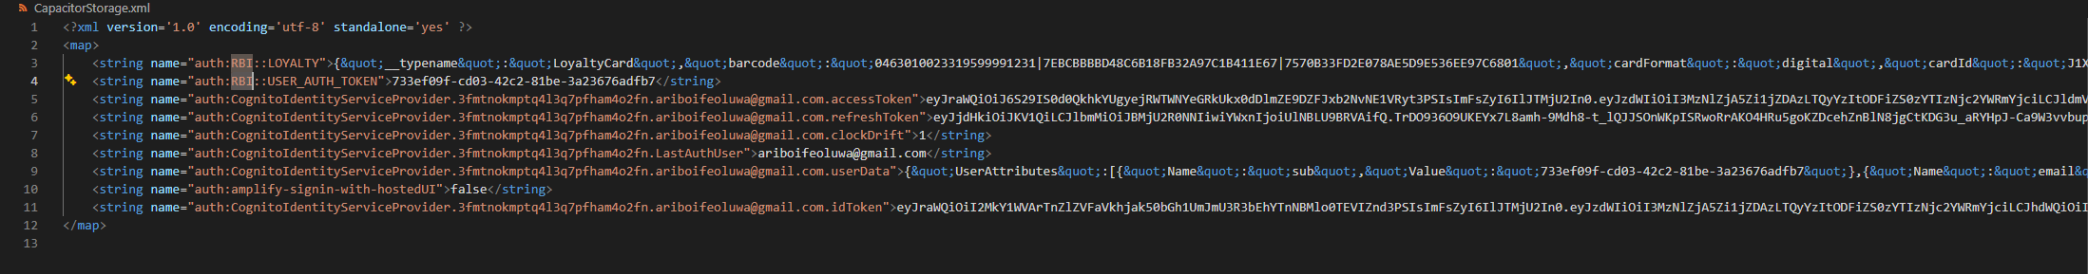
Impact: Full account compromise, unauthorized API access, privilege escalation.

2. Personal Identifiable Information (PII) - Exposure : HIGH SEVERITY
Files: Multiple XML files containing user data
Exposed PII:
- Email address: ariboifeoluwa@gmail.com
- User UUID: 733ef09f-cd03-XXXX-81be-XXXXXX
- Loyalty card details with cryptographic barcode data
- Device identifiers and usage patterns
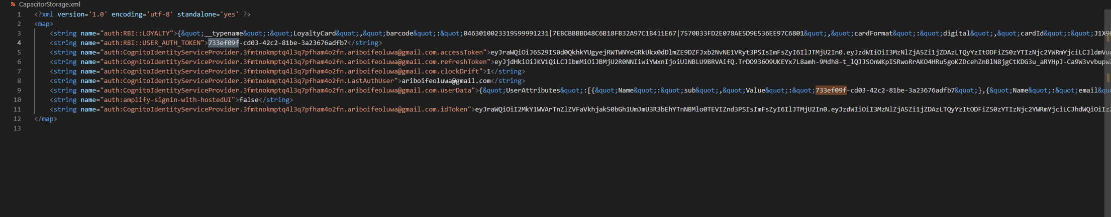
3. Loyalty Card Information - Exposure: MEDIUM SEVERITY
File: CapacitorStorage.xml
Exposed Data:
xml
<string name="auth:RBI::LOYALTY">{"__typename":"LoyaltyCard","barcode":"0463010023XXXXXX31|7EBCBXXXXXXD48C6B18FB32XXXXXXXXX|7570B33FD2E078AE5D9XXXXXX97C6801","cardFormat":"digital","cardId":"J1X9FPXXXXX","cardType":"AccumulateRedemptions","name":"???"}</string>

4. Analytics and Tracking Identifiers - MEDIUM SEVERITY
Identifiers Found:
- Adobe Experience Cloud ID: 23742544632453731637381779266751293723
- Firebase App Instance ID: ad84808690a15205f706c8b77dd516d8
- Multiple device fingerprinting identifiers
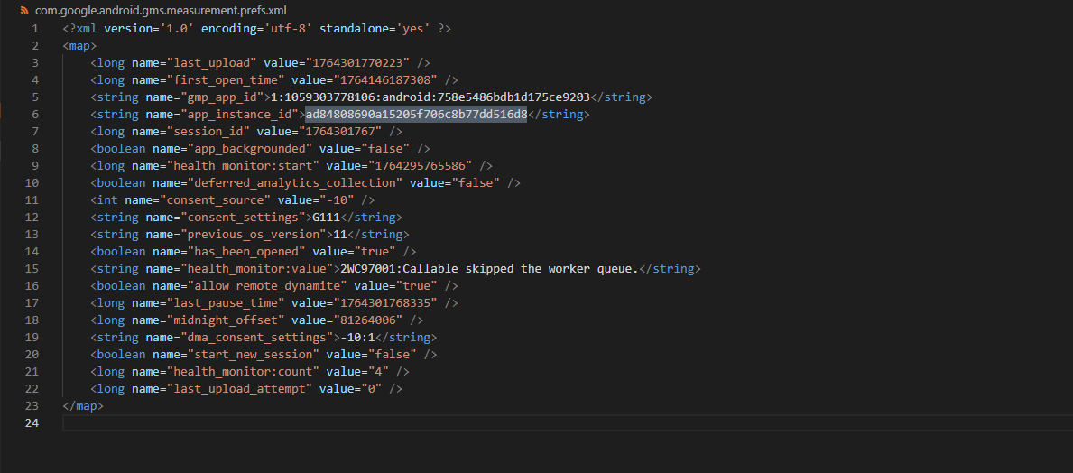
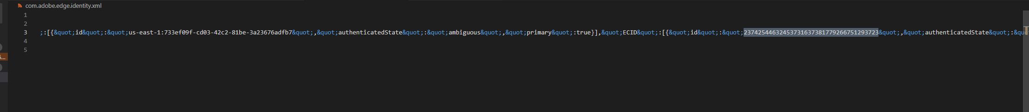

Security Posture Summary
Component | Security Status | Risk Level | Notes
SQLite Databases | ✅ Secure | LOW | No sensitive data exposure detected
Shared Preferences | ❌ Vulnerable | HIGH | Critical authentication data exposed
Authentication | ❌ Compromised | HIGH | Tokens in plaintext
Data Encryption | ⚠️ Partial | MEDIUM | Mixed implementation
Privacy Compliance | ❌ Non-compliant | HIGH | PII exposure issues
Technical Analysis Details
Database Security (Secure Implementation)
- Proper data classification and segregation
- No credential storage in database tables
- Appropriate encryption for sensitive fields
- SQL injection protections in place
- Secure database permissions
Shared Preferences Vulnerabilities
- No encryption applied to sensitive data
- Lack of Android Keystore integration
- World-readable storage locations
- Long-lived token storage without secure containers
- Insecure credential persistence
Authentication Flow Issues
- Tokens with admin privileges stored insecurely
- Refresh tokens exposed despite JWE encryption
- No token binding to device characteristics
- Inadequate session management

🛠️ Remediation Recommendations
Immediate Actions (Critical)
- Encrypt shared preferences using Android Keystore
- Implement secure token storage with biometric authentication
- Use EncryptedSharedPreferences for sensitive data
- Apply MODE_PRIVATE for all shared preference files
- Implement certificate pinning for API communications
Database Security (Maintain)
- Continue current secure database practices
- Maintain proper data segregation
- Preserve existing encryption implementations
Authentication Improvements
- Implement token binding to device fingerprints
- Use short-lived tokens with secure refresh mechanisms
- Never store tokens in shared preferences
- Implement proper session invalidation
Compliance Measures
- Conduct GDPR/CCPA compliance review
- Implement proper data minimization
- Establish data retention policies
- Enhance user consent mechanisms

Conclusion
The Tim Hortons Android app demonstrates a split security personality:
- STRENGTH: Secure database implementation with proper data handling
- CRITICAL WEAKNESS: Insecure shared preferences exposing authentication tokens and PII
Overall Risk Rating: HIGH - Due to the critical nature of exposed authentication tokens and PII
Priority: Immediate remediation required for shared preferences security while maintaining current database security standards.
The app requires urgent attention to secure the shared preferences storage to prevent potential account compromise and data breaches, while the database layer serves as a model of proper secure implementation.

